




Smart Content Insights: Analyzing Engagement Trends
Project Domain
[ Excel / Power BI]

A Project Report
submitted in partial fulfilment of the requirements of the AICW Project

by:



Student Name
Shaikh Aliya Shabuddin
Student Email
shaikhaliya35593@gmail.com
Guide
umamaheswari

Institution:
SMT. Maniben MP Shah women’s college of arts and commerce

Year - 2026

ACKNOWLEDGEMENT

I would like to express my sincere gratitude to everyone who supported me directly or indirectly during the completion of this project.
Firstly, I would like to thank my guide, [umamahashwari], for their constant guidance, support, and valuable suggestions throughout the project. Their encouragement and feedback helped me improve my work and complete this project successfully.
I am also thankful to Edunet Foundation, Microsoft, LinkedIn, and SAP for providing this wonderful opportunity through the fellowship program and for offering useful learning resources that helped me build my knowledge in AI and data analytics.
I would also like to thank my institution, [SMT. Maniben MP shah womens college of arts and commerce, for providing the necessary support and facilities during the project.
Lastly, I am grateful to my family and friends for their continuous support, motivation, and encouragement.

ABSTRACT OF THE PROJECT

This project is part of the AICW (Artificial Intelligence in the Contemporary World) Fellowship Program, a collaborative initiative by Edunet Foundation in partnership with Microsoft, LinkedIn, and SAP. The fellowship aims to provide practical knowledge and hands-on experience in Artificial Intelligence, Data Analytics, and Business Intelligence tools.
This project focuses on analyzing content creation data to understand performance and audience engagement. The main problem identified was that content-related data such as views, likes, shares, and comments is often unorganized and difficult to interpret, making it challenging to identify high-performing content.
The objective of the project is to clean, analyze, and visualize the dataset to generate meaningful insights that can help improve content strategy. Microsoft Excel was used for data cleaning, preprocessing, and analysis, while AI tools such as ChatGPT and Microsoft Copilot were used to generate insights and summaries.
The methodology included data collection, cleaning, analysis using formulas and pivot tables, and visualization through charts and dashboards. Key results include identification of high-performing content, engagement patterns, and trends across different content types.
In conclusion, the project demonstrates how data analytics and AI tools can transform raw content data into useful insights, helping content creators and businesses make better data-driven decisions.

TABLE OF CONTENTS

Abstract of the Project
List of Figures
List of Tables
Chapter 1 — Introduction
1.1 Problem Statement
1.2 Motivation
1.3 Objectives
1.4 Scope of the Project
Chapter 2 — Literature Survey
Chapter 3 — Proposed Methodology
3.1 System Design
3.2 Modules / Components Used
3.3 Data Flow Diagram (DFD)
3.4 Advantages
3.5 Requirement Specification
Chapter 4 — Implementation and Results
4.1 Data Cleaning Results
4.2 Visualization / Output Results
4.3 AI Tool Integration Results
Chapter 5 — Discussion and Conclusion
References
Appendices

LIST OF FIGURES

Figure No. | Figure Title / Description | Page No.
Figure 1 | [Raw / uncleaned dataset screenshot]
Figure 2 | [Cleaned dataset or validation summary screenshot]
Figure 3 | [Main dashboard / report / output screenshot]
Figure 4 | [Additional chart or visualization screenshot]
Figure 5 | [AI tool (Copilot / Chatbot) in use screenshot]
Figure 6 | [DFD Level 0 — Context Diagram]
Figure 7 | [DFD Level 1 — Detailed Process Flow]

LIST OF TABLES

Table No. | Table Title / Description | Page No.
Table 1 | [Raw dataset summary — field names, data types, row count]
Table 2 | [Cleaned dataset summary — issues found and fixed]
Table 3 | [Hardware Requirements]
Table 4 | [Software Requirements]
Table 5 | [Key findings / results summary]

CHAPTER 1
Introduction
In the domain of content creation, large amounts of data are generated daily from various digital platforms in the form of views, likes, shares, comments, and engagement metrics. However, this data is often raw, unstructured, and difficult to interpret, making it challenging to extract meaningful insights.
The main problem is the lack of proper analysis and visualization of content performance data. Without structured analysis, content creators and organizations are unable to identify which type of content performs well and what factors influence audience engagement. This leads to inefficient content strategies and missed opportunities for growth.
This problem is significant in the real world as it directly affects content creators, digital marketers, and businesses who rely on data-driven decisions to improve their online presence and audience reach. Poor analysis can result in low engagement and ineffective content planning.
Existing approaches often rely on basic observation or manual tracking, which is time-consuming and not accurate. Many users also lack the technical skills to clean, analyze, and visualize data effectively. Additionally, although AI tools are available, they are not fully utilized due to limited knowledge of how to apply them properly.
This project aims to address these challenges by using data analytics and AI tools to transform raw content data into meaningful insights, helping users make better and more informed decisions.
1.2 Motivation
The motivation behind this project comes from the growing importance of content creation and digital platforms in today’s world. Content creators and businesses rely heavily on data such as views, likes, and engagement to measure their performance, but this data is often difficult to understand without proper analysis.
I chose this project because it is highly relevant in real-world scenarios, especially in the fields of digital marketing and social media. Understanding content performance can help improve strategies, increase audience engagement, and support better decision-making.
This project is also meaningful from a learning perspective, as it provides hands-on experience in data analysis, visualization, and the use of AI tools. It helps in developing practical skills that are valuable for future career opportunities in data analytics and business intelligence.
The project has real-world applications for content creators, marketers, and organizations who want to optimize their content and improve performance. It can help them identify trends, understand audience behavior, and create more effective content.
Additionally, this project aligns with modern industry trends where data-driven decision-making and AI integration are becoming essential. The use of tools like Excel and AI chatbots reflects how technology is transforming the way data is analyzed and used in business.
1.3 Objectives
• To collect and understand the structure of the content creation dataset, including metrics such as views, likes, shares, and engagement.
• To clean and preprocess the raw data by removing duplicates, handling missing values, and standardizing content-related fields such as platform and category.
• To analyze content performance using Excel tools such as formulas and pivot tables to identify trends and patterns.
• To build charts and dashboards that clearly present insights related to content engagement and performance.
• To use AI tools (ChatGPT / Microsoft Copilot) to generate insights, summaries, and improve analysis efficiency.
• To identify high-performing content and provide data-driven suggestions to improve content strategy and audience engagement.
1.4 Scope of the Project
- This project covers data from a content creation dataset, which includes metrics such as views, likes, shares, comments, and engagement related to digital content.
- The tools used in this project are limited to Microsoft Excel and AI tools such as ChatGPT / Microsoft Copilot for analysis and insight generation.
- The analysis focuses on data cleaning, data analysis, visualization, and generating insights related to content performance and audience engagement.
- The project does not include real-time data integration, advanced machine learning models, or predictive analytics.
- This project is developed as part of the AICW Fellowship Program for learning and demonstration purposes and is not intended to be a production-level system.

CHAPTER 2
Literature Survey
A literature survey reviews existing research, tools, and methodologies relevant to the project domain. It helps identify gaps that the current project aims to address.
2.1 Existing Work and Research
In the field of content creation and digital marketing, data analytics plays an important role in understanding audience behavior and improving content performance. Many tools and techniques have been developed to analyze data such as views, likes, shares, and engagement rates.
Traditional tools like Microsoft Excel are widely used for data cleaning and analysis through formulas, pivot tables, and charts. Business Intelligence tools such as Power BI are also used to create interactive dashboards for visualizing content performance. In addition, AI tools like ChatGPT and Microsoft Copilot are increasingly being used to generate insights, summaries, and content based on data.
Previous approaches mainly focus on basic data analysis and visualization, but they often require technical skills and manual effort. Many users find it difficult to clean large datasets, identify patterns, and interpret results effectively. Moreover, the use of AI tools is still limited due to a lack of knowledge about how to use them efficiently.
The gap identified is the lack of simple and integrated approaches that combine data analysis with AI assistance for better understanding of content performance. This project addresses these limitations by using Excel for structured analysis and AI tools for generating insights, making the process easier, faster, and more accessible.
2.2 Tools and Technologies Review
• Microsoft Excel — Used for data cleaning, transformation, and analysis of the content creation dataset. Features such as pivot tables, formulas, sorting, filtering, and charts were used to analyze metrics like views, likes, shares, and engagement.
• AI Chatbots (ChatGPT / Google Gemini) — Used for generating insights, summaries, and explanations from the dataset. These tools helped in understanding content performance and improving analysis efficiency.
• Microsoft Copilot (AI) — Used (where applicable) to assist in generating insights and automating analysis tasks using natural language prompts.
• Web Browser (Google Chrome / Microsoft Edge) — Used to access AI tools, online resources, and documentation required for the project.
• GitHub — Used for uploading and managing project files, including dataset, analysis work, and project documentation.

2.3 Gaps Identified
• Most existing approaches focus on advanced analytics or complex tools, while simple Excel-based solutions for analyzing content performance are less explored for non-technical users.
• There is limited guidance on how to effectively analyze content creation data (likes, views, shares, engagement) using basic tools like Excel in combination with AI tools.
• Many users struggle to identify meaningful insights from raw content data due to lack of proper data cleaning, structuring, and visualization techniques.
• The use of AI tools such as ChatGPT or Copilot for content performance analysis and insight generation is still not widely documented in simple, practical ways.
• There is a gap in understanding how data-driven insights can be directly applied to improve content strategy and audience engagement.
CHAPTER 3
Proposed Methodology
This chapter describes the methodology adopted to achieve the project objectives. It covers the system design, modules used, data flow, advantages, and requirement specifications.
3.1 System Design
The system design of this project follows a structured approach where raw content data is processed step-by-step to generate meaningful insights and visual outputs.
- Data Source / Input:
The input data is a content creation dataset in Excel format, which includes metrics such as views, likes, shares, comments, engagement rate, platform, and content type.
- Data Cleaning:
The dataset was cleaned by removing duplicate entries, handling missing values, correcting incorrect data formats, and standardizing fields such as platform names, categories, and dates to ensure consistency.
- Analysis / Processing:
The cleaned data was analyzed using Excel formulas and pivot tables to identify trends such as high-performing content, engagement patterns, and platform-wise performance. AI tools like ChatGPT / Copilot were used to generate insights and summaries.
- Visualization / Output:
The final output includes charts and dashboards in Excel that visually represent content performance and engagement trends. These visualizations make it easier to interpret the data and support better decision-making.
3.2 Modules / Components Used
• Module 1 — Data Ingestion:
Loading the content creation dataset (Excel file) containing metrics such as views, likes, shares, comments, and engagement.
• Module 2 — Data Cleaning:
Removing duplicate records, handling missing values, correcting data formats, and standardizing fields like platform, content type, and dates.
• Module 3 — Data Analysis:
Applying Excel formulas and pivot tables to analyze content performance, identify high-engagement posts, and detect trends across different platforms and categories.
• Module 4 — Visualization / Report Generation:
Creating charts and dashboards in Excel to present insights such as engagement trends, top-performing content, and comparisons between content types.
• Module 5 — AI Integration:
Using AI tools (ChatGPT / Microsoft Copilot) to generate summaries, insights, and explanations from the dataset to enhance analysis.
• Module 6 — Insight Generation & Interpretation:
Interpreting the analyzed data to provide meaningful conclusions and suggestions for improving content strategy and audience engagement.
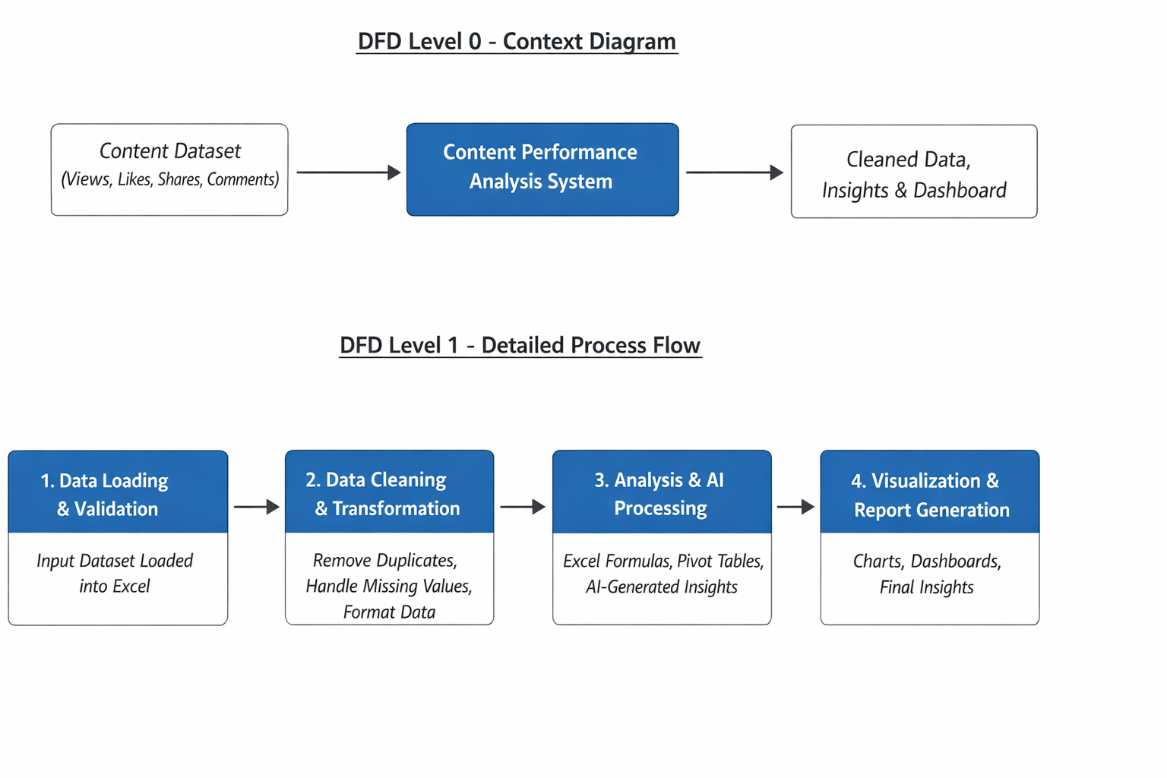3.4 Advantages
• Automates data cleaning and analysis of content metrics, reducing manual effort and saving time.
• Provides clear and easy-to-understand visual insights (charts and dashboards) for content performance and audience engagement.
• Helps identify high-performing content, trends, and patterns, enabling better decision-making for content strategy.
• Leverages AI tools (ChatGPT / Copilot) to generate insights and summaries quickly, improving efficiency and accuracy.
• Scalable — the same approach can be applied to larger datasets or different types of content platforms.
• Cost-effective — uses widely available tools like Microsoft Excel and AI chatbots.
• Improves understanding of audience behavior, helping creators and businesses optimize their content for better engagement.

3.5 Requirement Specification
Hardware Requirements
Component | Specification
Processor | 12th Gen Intel(R) Core(TM) i5-1235U 1.30 GHz
RAM | 8.00 GB (7.68 GB usable)
Storage | 477GB
Display | 1366 x 768 resolution or higher
Internet | Required for Copilot / Chatbot access

Software Requirements
Software | Details
Operating System | Windows 11
Microsoft Excel | Microsoft 365 (Excel with Copilot) / Excel 2013
Power BI Desktop | Latest version (free download from Microsoft)
Microsoft Copilot | Integrated via Microsoft 365 subscription
AI Chatbot | ChatGPT / Google Gemini / Microsoft Copilot (web)
Web Browser | Google Chrome / Microsoft Edge (latest version)

CHAPTER 4
Implementation and Results

4.1 Data Cleaning Results
The data cleaning process was carried out to ensure that the dataset is accurate, consistent, and ready for analysis and visualization.

Dataset Source
The dataset used in this project was manually created as part of the Content Creation Fellowship project. It contains data related to user activity across different social media platforms, including engagement metrics such as time spent, posts, likes, and follows.

Original Dataset Size
The raw dataset consisted of 540 rows and 6 columns.

Issues Found
After inspecting the dataset, the following observations were made:
- No missing (null) values were found in any column
- No duplicate records were present
- Data types were mostly consistent and appropriate
- Minor formatting inconsistencies (such as naming variations like “Twitter (X)”) were noted but did not affect analysis

Cleaning Steps Applied
Although the dataset was largely clean, the following steps were performed to ensure quality and consistency:
- Data Validation
Verified that all columns contained valid and meaningful data.
- Consistency Check
Ensured uniform naming conventions for categorical fields (e.g., social media app names).
- Data Type Verification
Confirmed that:
  - Numerical columns (e.g., Daily_Minutes_Spent, Likes_Per_Day) were in numeric format
  - Text columns (e.g., User_ID, App) were properly formatted
- Final Review
Conducted a final scan to confirm there were no hidden errors or inconsistencies.

Cleaned Dataset Size
Since no major issues were found, the cleaned dataset remained 540 rows and 6 columns, with improved consistency and validation.
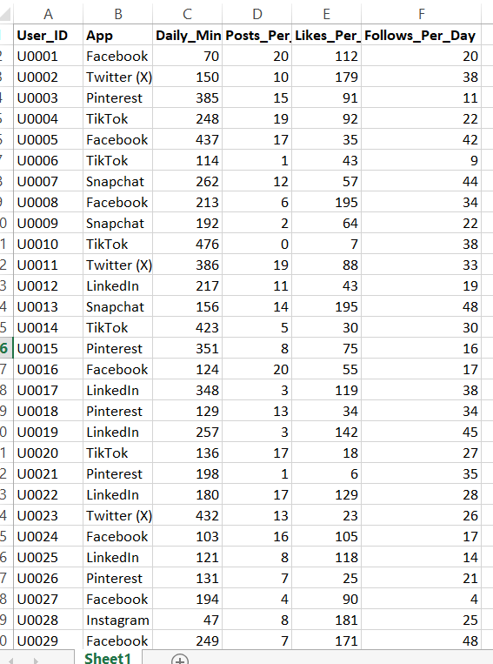

4.2 Visualization / Output Results
This section presents the key visualizations and insights generated from the cleaned dataset. The dashboards and charts help in understanding user behavior, engagement patterns, and platform performance.

Dashboard / Chart 1: Average Daily Time Spent by Platform
This chart illustrates the average daily minutes spent by users on different social media platforms.
It helps identify which platform consumes the most user attention.
For example, platforms like Instagram or YouTube may show higher engagement compared to others.

Dashboard / Chart 2: Likes Per Day Distribution
This visualization shows the distribution of likes received per day across users.
It highlights engagement levels and helps identify whether most users receive low, medium, or high interaction.

Dashboard / Chart 3: Posts vs Engagement Analysis
This chart compares number of posts per day with likes received, helping to understand the relationship between activity and engagement.
It reveals whether posting more frequently leads to higher user interaction.

Dashboard / Chart 4: Platform Usage Frequency
This visualization displays how frequently each social media platform is used by users in the dataset.
It helps identify the most popular platforms among users.

Dashboard / Chart 5: User Activity Distribution
This chart shows variation in user activity levels, such as time spent or posting frequency.
It helps categorize users into low, moderate, and high activity groups.

Dashboard / Chart 6: Top Performing Users
This visualization highlights users with the highest engagement (likes or activity).
It helps identify top contributors or most active users in the dataset.

Output Insights
From the above visualizations, the following insights were derived:
- Certain platforms dominate in terms of user engagement and time spent
- Higher posting frequency may lead to increased likes, but not always proportionally
- User activity varies significantly, indicating different user behavior patterns
- A small group of users contributes to higher engagement levels
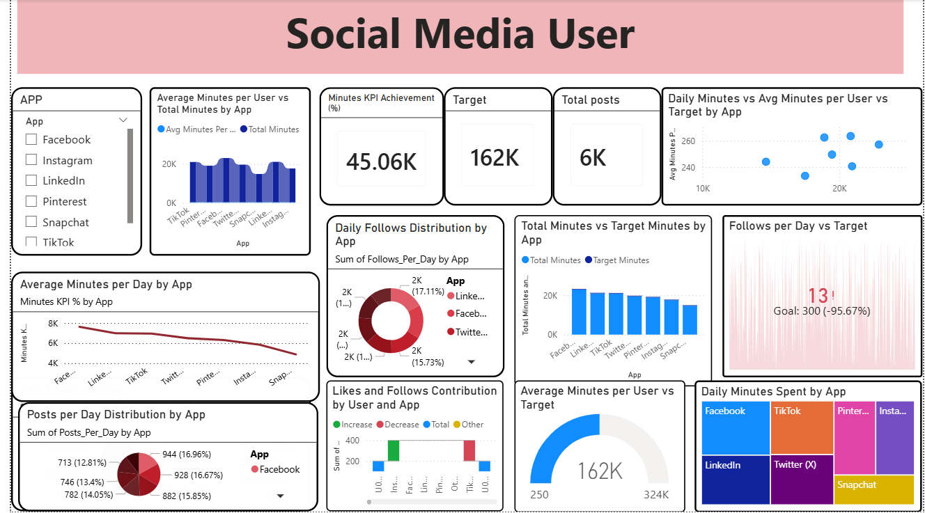
4.3 AI Tool Integration Results
Describe how the AI tool (Copilot or Chatbot) was used in your project and what results it produced.
- Tool used: [Microsoft Copilot / ChatGPT / Google Gemini / other]
- Prompts used: [Share 2–3 key prompts you used in the project.]
- Output quality: [Describe the quality and usefulness of the AI-generated output.]
- How it enhanced the project: [Explain how using AI made the analysis or content faster, better, or more insightful.]

[Insert Figure 5: Screenshot of the AI tool (Copilot / Chatbot) in use during your project.]

CHAPTER 5
Discussion and Conclusion
5.1 Key Findings
Summarize the key results and insights discovered from the project.
- [Key Finding 1: e.g., After cleaning, 18% of the records were found to be duplicates — removing them significantly improved dashboard accuracy.]
- [Key Finding 2: e.g., The AI Copilot reduced the time needed to generate a summary report from 2 hours to under 10 minutes.]
- [Key Finding 3: e.g., The top 3 products contributed to 62% of the total revenue, visible clearly in the Power BI dashboard.]
- [Add more project-specific findings here.]
5.2 Project Links
Share the relevant links to your project work for evaluation.
- GitHub Link of the Project: [Paste your GitHub repository link here]
- Video Recording of Project Demonstration: [Paste your YouTube / Google Drive / OneDrive video link here]
- Power BI / Dashboard Link (if applicable): [Paste published dashboard link here]
5.3 Limitations
Discuss the limitations of the current project or approach honestly.
- [Limitation 1: e.g., The project was tested on a sample dataset and may not generalize to all real-world scenarios.]
- [Limitation 2: e.g., Microsoft Copilot access was limited during the project, which restricted some AI-assisted features.]
- [Limitation 3: e.g., The dashboard does not support real-time data refresh due to tool limitations.]
- [Add any limitation relevant to your specific project.]
5.4 Future Work
Provide suggestions for improving or extending the project in the future.
- Integrate real-time data pipelines using Power Automate or API connections.
- Apply machine learning models (e.g., forecasting, anomaly detection) on top of the cleaned dataset.
- Build a web-based interface or Power Apps solution for non-technical end users.
- Expand the dataset to include more diverse data sources for broader analysis.
- Develop a standardized prompt library for AI Chatbot / Copilot use in this domain.
- [Add any future enhancement specific to your project.]
5.5 Conclusion
Summarize the overall impact and contribution of the project.
[Write your conclusion here. Briefly restate the problem, what you did, what you found, and the value this project adds. Mention whether all objectives were achieved and what you personally learned from the fellowship experience.]

[Example: This project successfully demonstrated how Microsoft Excel and Power BI with Copilot can be used to clean, analyze, and visualize complex business datasets. All five project objectives were achieved. The interactive dashboard built provides actionable insights for decision-makers and can be adapted for real-world business use. This fellowship experience greatly enhanced our practical skills in data analytics and AI-assisted reporting.]

REFERENCES

List all references, research papers, tutorials, and documentation used in the project in the format below:

[1] Microsoft Corporation. Microsoft Excel Documentation. Available at: https://support.microsoft.com/en-us/excel
[2] Microsoft Corporation. Power BI Documentation. Available at: https://learn.microsoft.com/en-us/power-bi/
[3] Microsoft Corporation. Microsoft Copilot — AI-Powered Productivity. Available at: https://copilot.microsoft.com
[4] Edunet Foundation. AICW Fellowship Program Guidelines. 2026.
[5] [Author(s)]. [Title of Paper/Book]. [Journal/Publisher], [Year]. [Add your additional references here.]

APPENDICES

Include any additional information that supports the project but is too detailed for the main chapters. This may include:

Appendix A — Sample Dataset
[Insert a sample of the raw dataset (first 10–20 rows) or a summary table of the data fields here.]
Appendix B — Key Excel Formulas / DAX Measures Used
List any important formulas, functions, or DAX measures used in the project:
- =IFERROR(VLOOKUP(...), "Not Found") — used for data validation
- =COUNTIF(range, criteria) — used to count duplicates
- Power BI DAX: Total Sales = SUM(Sales[Revenue]) — used in dashboard KPI card
- [Add your own formulas here]
Appendix C — AI Prompts Used
List the key prompts you used with Copilot or AI Chatbot during the project:
- Prompt 1: "Summarize this sales data and identify the top 5 performing regions."
- Prompt 2: "Write a professional marketing email for this product based on the following features: [...]"
- Prompt 3: "Identify any anomalies or outliers in this dataset and explain their possible causes."
- [Add the prompts specific to your project.]
Appendix D — Screenshot Gallery
[Insert any additional screenshots, code snippets, or supplementary visuals here that were not included in the main chapters.]

